**Software Requirements**

**Specification**

**For**

**Meeting Room**

**Booking System**

**(MRBS)**

**Version 0.3**

**Prepared by K15T1-Team11**

**Van Lang University**

**Jun 17, 2012**

**Table of Contents**

1. Introduction 1

**1.1.** **Purpose** 1

**1.2.** **Scope** 1

**1.3.** **Definitions, acronyms, and abbreviations** 1

**1.3.1.** **Definitions** 1

**1.3.2.** **Acronyms** 1

**1.4.** **References** 1

**1.5.** **Overview** 1

2. Overall Description 2

**2.1.** **Product Perspective** 2

**2.2.** **Product Feature** 2

**2.3.** **Primary Actors:** 2

**2.4.** **Operating Environment** 2

3. Specific Requirement 2

**3.1.** **External Interface Requirements** 2

**3.1.1.** **User Interfaces** 2

**3.1.1.1.** **User Interfaces architecture** 3

**3.2.** **System Features** 3

**3.2.1.** **Use case diagram** 3

**3.3.** **Software Quality Attributes** 4

**3.3.1.** **Performance Requirements** 4

**3.3.2.** **Usability Requirements** 4

**3.3.3.** **Other Requirements** 4

**Revision History**

|  |  |  |  |
| --- | --- | --- | --- |
| Version | Name | Date | Reason for Changes |
| 0.1 | Tam Do | Jun 16, 2012 | 1st Draft |
| 0.2 | Tam Do | Jun 16, 2012 | 2nd Draft |
| 0.3 | Tam Do | Jun 17, 2012 | 3rd Draft |
|  |  |  |  |

1. **Introduction**
   1. **Purpose**

The SRS document created by the team 11 provides both the functional and non-functional requirements of the Meeting Room Booking System (MRBS). This document includes definitions, specifications, and other information that will be helpful for the customer and for the team 11 to have a clear understanding of the system to be developed.

From this document, the customer will be able to understand our team’s comprehension of the requirements. This document can be updated or revised when required by the customer as we consider our customer’s demands important for our project. This document will evolve according to the requirement.

* 1. **Scope**

MRBS is a small system that can be easily managed the meeting room, import file excel, statistic and report for IT department of the Van Lang University, and use for one branch, one computer.

* 1. **Definitions, acronyms, and abbreviations**
     1. **Definitions**

|  |  |
| --- | --- |
| Term | Definition |
|  |  |

* + 1. **Acronyms**

|  |  |
| --- | --- |
| Acronyms | Abbreviations |
| SRS | Software Requirement Specification |
| HPIMS | HMC POI Inspection & Management System |
| GUI | Graphical User Interface |
| CMU | Carnegie Mellon University |
| FC | Function |
| FT | Feature |

* 1. **References**

HPIMS_SRS_v1.03.doc of CMU

* 1. **Overview**

The rest of this SRS is organized as follows:

* In section 2, the project overview is described. We have also given information on what and how we will handle the project.
* In section 3, the detailed functional and non-functional requirement is described in a way that no ambiguous aspects are left.

1. **Overall Description**
   1. **Product Perspective**

MRBS is aimed toward a person who has considerable number of registry meeting room in IT department, and so needs software assistance for book meeting room and computations regarding the priority. MRBS should be user friendly, quick to learn and reliable software for above purpose.

* 1. **Product Feature**

MRBS should support the following feature:

* Account Management
  + User can create a new account, view information about the account, edit MRBS password an existing account, search, lock/unlock account, and sign in/sign out MRBS.
* Borrower Management
  + User can create a new borrower, or import a list of borrower by excel (*.xls), view, edit or search information about the borrower.
* Room Borrow Management
  + User can register a meeting room, check in/check out for borrower, change, search information about meeting room or approve/reject every request to borrow meeting room.
* Statistic and Report
  + User can view report about the meeting room, borrower violation, …
* Room Management
  + User can create a new room, and view, edit or search information about the room.
* Floor Management
  + User can create a new floor, and view, edit or search information about the floor.
* Setting – Priority, Email
  + This feature is used to set automatic priority when the borrower register meeting room and content for email.
  1. **Primary Actors:**

The two primary actors in MRBS are user and system.

* 1. **Operating Environment**

The target system is a standalone application in a PC environment on Microsoft Windows XP, 7 with Microsoft SQL Server 2008.

The system will be developed using platform-independent C# language.

1. **Specific Requirement**
   1. **External Interface Requirements**
      1. **User Interfaces**

This user interface is prototype made after discussion among team 11. This will help the client to see the user interface of our final program artifact in this project. The contents and appearance can be changed or refined based on the user’s requirement and technical constraints.

* + - 1. **User Interfaces architecture**

This is the overall architecture of MRBS prototypical user interface. The user interface is divided into three, mainly based on the functions of MRBS.



* 1. **System Features**
     1. **Use case diagram**

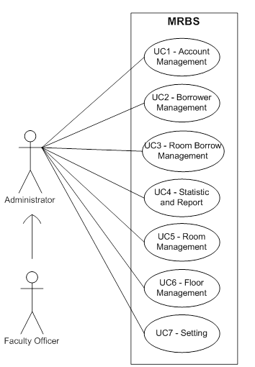

|  |  |  |
| --- | --- | --- |
| Use Case ID | Use Cases | Primary Actor |
|  |  |  |
|  |  |  |
|  |  |  |
|  |  |  |
|  |  |  |
|  |  |  |
|  |  |  |

* 1. **Software Quality Attributes**
     1. **Performance Requirements**
     2. **Usability Requirements**
     3. **Other Requirements**